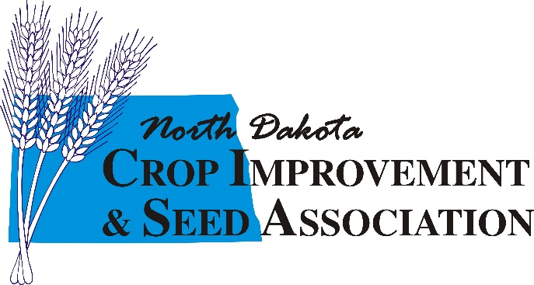

2023 NDCISA COUNTY DUES

Established in 1929, North Dakota Crop Improvement and Seed Association (NDCISA) is a non-profit organization supported by county dues, producer memberships and research fees from the seed increase program. NDCISA works closely with the North Dakota Agricultural Experiment Station and NDSU Extension to support ag. research, promote general crop improvement practices, increase varieties best adapted to the region, and to make the seed easily available to producers.

The NDCISA annual county dues are $100.00.

If you have any questions, contact: Toni Muffenbier (701)893-6069 or (toni@ndcropimprovement.com)

Please mail form and payment to: North Dakota Crop Improvement and Seed Association
PO Box 5084
West Fargo, ND 58078

COUNTY NAME:

